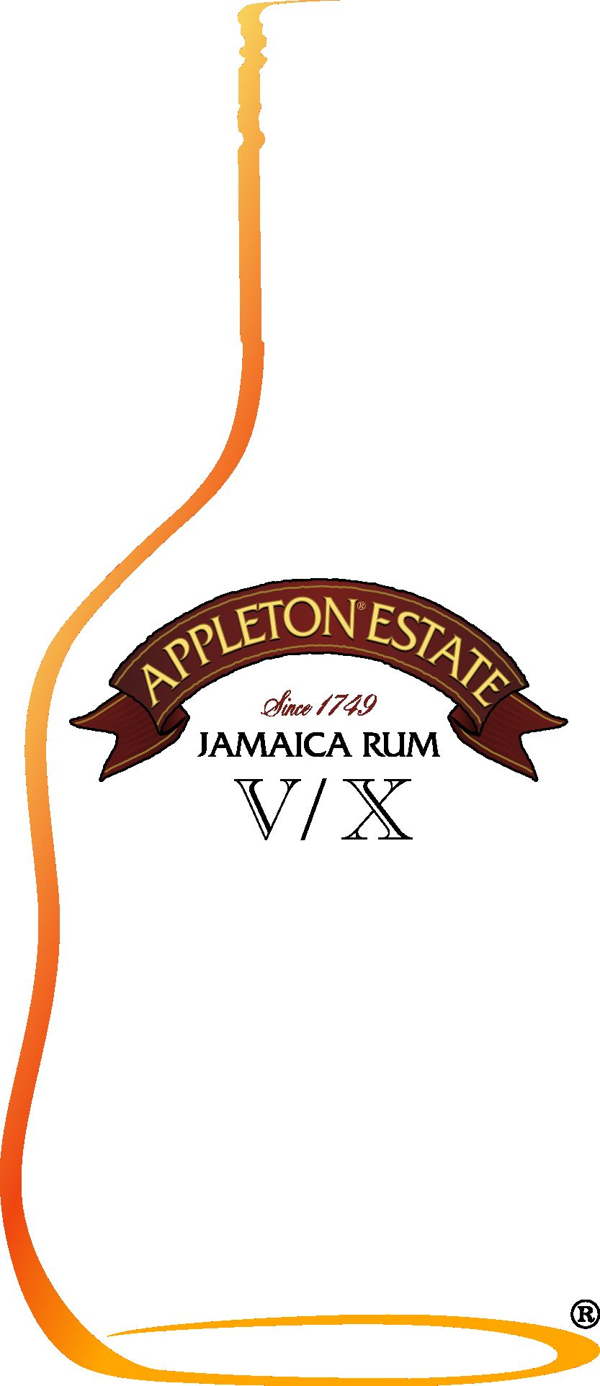

WHAT’S GOING TO BE ON EVERYONE’S LIPS IN 2004

Prada, Gucci, Fiorucci…….the fashion conscious know when buying a label they are guaranteed consistent good quality and cutting edge design. Experts predict that the latest trend for style setters in 2004 is going to be the labelled cocktail.

Celebrity icons have always used labelled champagne to portray cult status. However, with champagne being so accessible, trendsetters are now looking for the next vogue. With the fashion pack turning to cocktails as the next big drink, they also bring with them their label conscious demands.

Mixologists, or bartenders as they now like to be called, are hearing requests from the other side of the bar with the abbreviations of the alcoholic ingredient in front of the cocktail. This way the fashionable cocktail drinker can guarantee the same consistent quality from their drink as they can with their clothes.

With Jamaica seeing a huge revival in 2004; Sean Paul winning the MTV best newcomer award, the Caribbean as the ultimate holiday hangout for the rich and famous, gold rum is being tipped as the new cocktail must have.

Cont…/
If we look back at history when Trader Vic’s owner Jules Bergeron created the Mai Tai in 1944 he used aged gold from the Appleton Estate. Nowadays, history is repeating itself with mixologists using Appleton Estate V/X Jamaica Rum when being asked for the V/X Mai Tai.

The Mai Tai was given its name when Jules Bergeron created the cocktail and offered it to his Tahitian friends to try. Upon tasting the drink his friends exclaimed “Mai Tai-Roa Ae”, which in Tahitian means “out of this world – the best!” Now cocktail drinkers know that the only way to truly replicate ‘the best’ is to ask for a V/X Mai Tai.

Says Andreas Redlesfen, brand manager at Appleton “we run an academy here in the UK training the top mixologists from across the UK. There is no doubt that gold rum is one of the most versatile spirits for cocktails and the word from the bartenders is that it’s making a huge comeback. Cocktails drinkers know that to ensure a perfect Jamaican Mule or Voodoo is served they must first request V/X before the cocktail name.”

If you are serious about socialising make sure V/X is first on your lips.

- ends -
Editors Notes:
Appleton Estate VX Jamaica Rum is aged golden rum made with a blend of rums between 5 and 10 years old.

For further information please contact:
Lysbeth Fox or Hannah Wiltshire
Halpern
Tel: 020 7351 2888
Email: lysbeth@halpern.co.uk or hannah@halpern.co.uk

APPLETON ESTATE V/X JAMAICA RUM COCKTAILS

V/X Mai Tai

Description: A concoction of Appleton Estate V/X Jamaica Rum, orange curacao, fresh lime
juice, gomme and orange syrup all shaken together to create a refreshing V/X
Mai Tai.
Glass: Old-fashioned
Ingredients: 2 shots Appleton Estate V/X Jamaica Rum
1 shot freshly squeezed lime juice
½ shot orange curacao
½ shot orgeat (almond) syrup
½ shot sugar (gomme) syrup
Garnish: lime wedge (pineapple) & fresh mint
Method: shake with ice and strain into a glass filled with crushed ice

V/X Mule

Description: A taste of Jamaica! Appleton Estate V.X Jamaica Rum and Jamaican ginger
beer mixed together to create the perfect drink.
Glass: Highball
Ingredients: 2 shots Appleton Estate V/X Jamaica Rum
ginger beer
squeeze of lime
Garnish: lime wedge
Method: pour Appleton Estate V/X Jamaica Rum into a glass filled with ice, top off with
ginger beer and add a squeeze of lime.

V/X Voodoo

Description: A sweet taste sensation! Appleton Estate V/X Jamaica Rum, sweet vermouth,
fresh lime juice, apple juice and sugar syrup all shaken together to create a little
magic.
Glass: Highball
Ingredients: 2 shots Appleton Estate V/X Jamaica Rum
1 shot Rosso Vermouth
4 shots apple juice
juice from 1 lime
Garnish: ground cinnamon
Method: pour Appleton Estate V/X, Rosso Vermouth, apple juice and lime juice into a
cocktail shaker and shake with ice. Pour into highball glass over ice and garnish
with ground cinnamon.
Created by Alex Kammerling

